**Documentation**

For this Project I have launched my infrastructure as a code by using Terraform. I have created a VPC, Route table, Route53, Ec2(Ubuntu 18.04), 2 public subnets Internet gateway and Elastic Load balancer

**Note: Find The Infrastructure code attached in GitHub Repo**

Once we SSH into the machine it came up with the docker and nginx server installed in a container as we already mentioned in the script along with the terraform

**Commands used in Terraform**

Terraform init – it initializes the terraform

Terraform Plan- it will plan and notify any errors in our code

Terraform apply- it creates the infrastructure

My goal in this project is to serve the static content in a text file which shows the version Num 1.0.6 for achieving this I need to make some changes in the nginx configuration file as we already know by default nginx server goes to the /var/www/html looks for the static content in this path we add a directory named version and add index.txt file which serves our version number. I have changed the configuration in /etc/nginx/sites-enabled editing the default file by adding our version directory and index.txt. restarted the nginx server we come up with version number 1.0.6

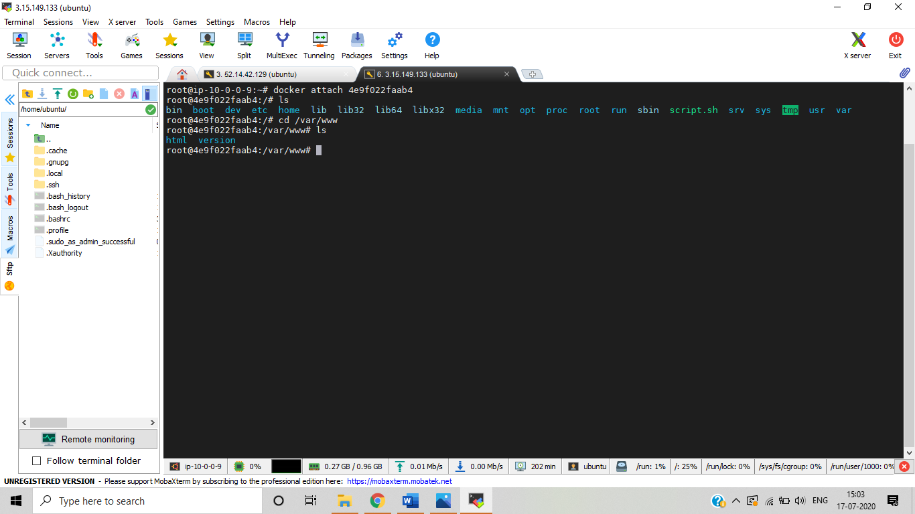

As I do some modifications in /etc/nginx/sites-enabled and edit the default file

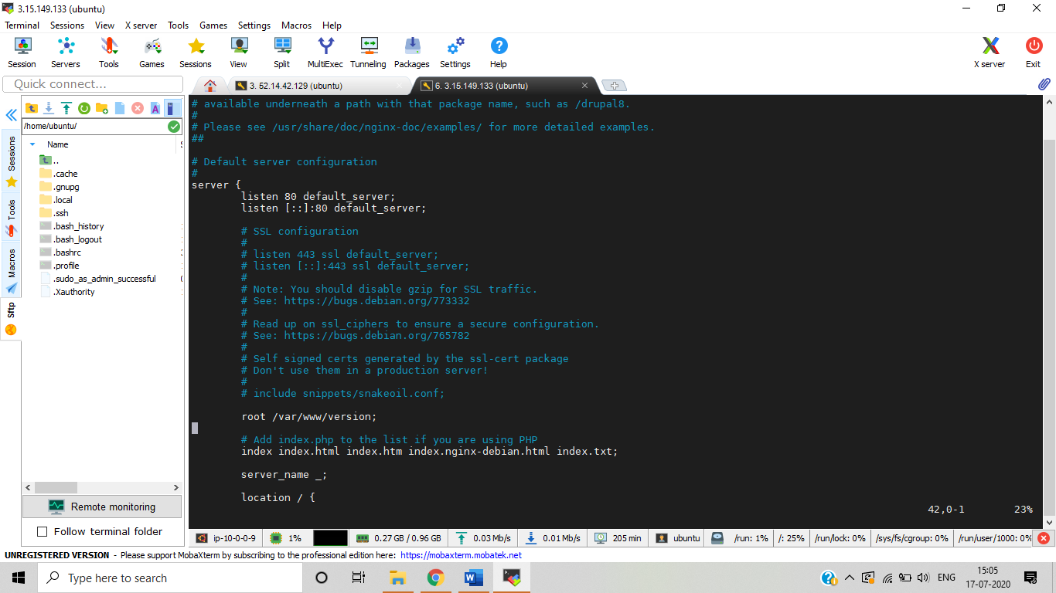

I wrote a bash script which runs for every 60 sec to check the server is up and serving with the version number 1.0.6

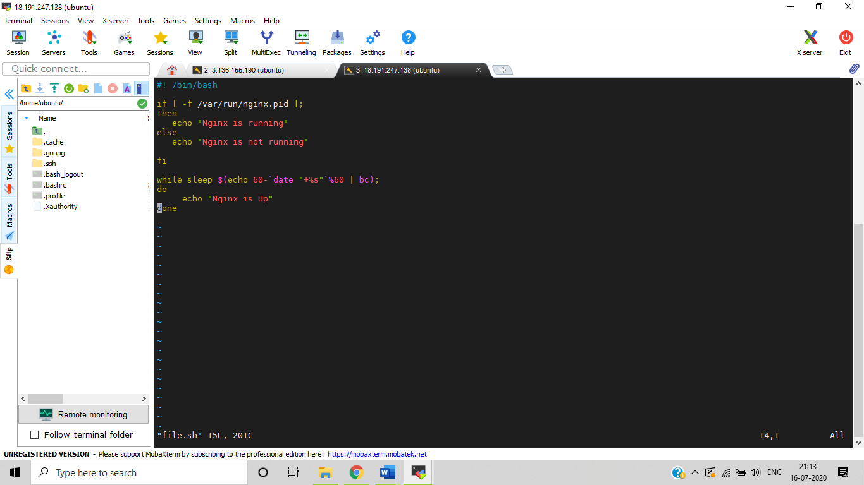

**Output of the script**

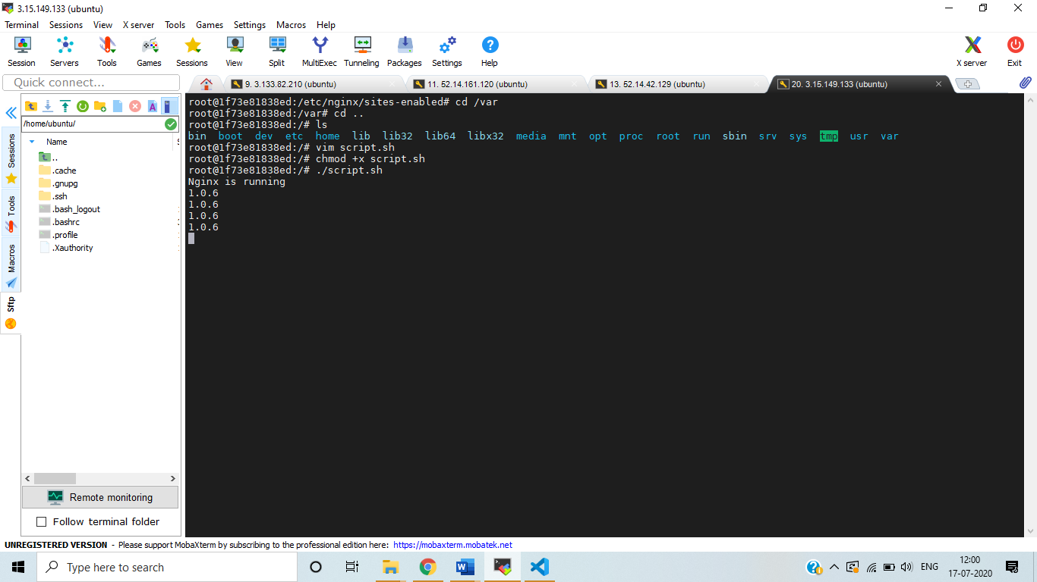

**SSL certificate**

For achieving SSL, I used letsencrypt. I made the container to run on port 90. I have enabled reverse proxy in host machine, so it directs the traffic receive from host machine to the container port.

I have created a free domain in freenom.com and I created record sets in AWS route53

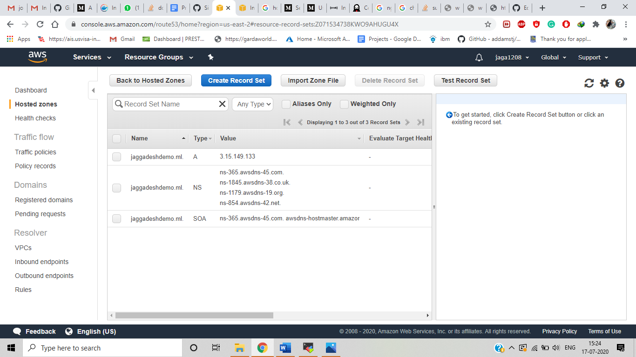

**Steps to achieve SSL**

1. **ADD Certbot PPA by following commands**

$ sudo apt-get update

$ sudo apt-get install software-properties-common

$ sudo add-apt-repository ppa:certbot/certbot

1. **Install certbot**

$ sudo apt -get install certbot python3-certbot-nginx

1. **Run certbot**

$Sudo certbot – nginx

1. **Test automation Renewal**

$sudo certbot renew –dry-run

For reverse Proxy we need to create a file under /etc/nginx/sites-enabled and add our domain name under server and mention the port num which it listens

Reverse proxy .conf

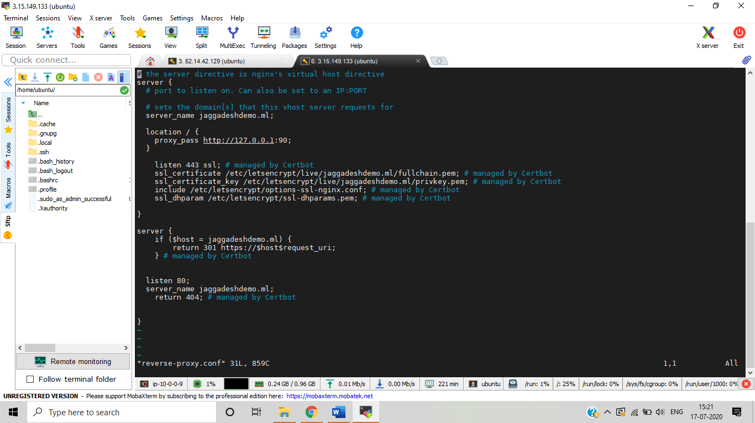

**SSL**

